INDIAN SCHOOL AL WADI AL KABIR
Chapter 4 (Book 2)- Change and Development in Rural Society (GRADE XII)
Question Bank

1.Read the passage given and answer the questions: (competency- based question):
The harsh working conditions suffered by laborers in Aghanbigha were an outcome of the combined effect of the economic power of the maliks as a class and their overwhelming power as members of a dominant caste. A significant aspect of the social power of the maliks was their ability to secure the intervention of various arms of the state to advance their interests. Thus, political factors decisively contributed to widening the gulf between the dominant class and the underclass.
(i)Why do you think the maliks were able to use the power of the state to advance their own interests? (ii)What were they able to do with their power? (iii) How could the maliks gain social power in Aghanbigha?
(iv) Why did labourers have harsh working conditions?
Ans. (i) The maliks being dominant caste were very powerful politically, economically and socially.
(ii)Because of power they were able to use the power of state for their vested interests.
(iii)They were successfully able to secure the intervention of various arms of the state for their own benefit.
(iv)The labour have been working under harsh conditions because being Dalits, they were not allowed to own land and compelled to work in the lands of dominant caste people as a labourer.
2. What measures do you think the government has taken, or should take, to protect the rights of landless agricultural labourers and migrant workers?
Ans. Measures to protect the right of Landless:
•Abolition of bonded labour legally:
Bandhua mazdoor (bonded labourers) practice in U.P and Bihar, Halpati System in Gujarat and Jeeta System in Karnataka has been legally abolished by Government of India.
•Abolition of Zamindari System: The intermediaries between the peasants and the state were the Zamindars. The state very effectively and intensively passed legislation and this system was abolished.
• Abolition and regulation act for Tenancy:
These laws discouraged tenancy or ‘Batai’ system. In West Bengal and Kerala, where CPI systems government was in power the tenants got the land rights.
•Imposition of Land Ceiling Act:
According to this act the upper limit of land for an owner is being fixed. Because of this act to identify surplus land and redistribute among the landless became programme of the state. Vinoba Bhave’s Bhoodan yojna instructed this legislation but there are many shortcomings in this act and should be taken care of.
•To improve the condition of landless people living in villages the state should take appropriate measures and this whole sector should be organized.
•The economic conditions of villages should be improved by the state. Villages should be well connected to the ties; job opportunities should be increased in the villages. Education and health facilities as well as entertainment facilities should be developed in the villages to discourage migration. MANREGA is an effective measure in this direction.
•Consolidation of Land: Landowner farmers are given one or two bigger piece of land in lieu of their several scattered small fields. It may be done as voluntary consolidation or as compulsory consolidation. This can bring about lot of efficiencies in agriculture process as a farmer.
3. There are direct linkages between the situation of agricultural workers and their lack of upward socio-economic mobility. Name some of them.
Ans. • Indian rural society is totally dependent on agriculture. It is the only source of their livelihood. Unfortunately, it is unevenly distributed, not organized and many people of rural Society are landless.
•Indian rural society has patrilineal kinship system. According to legal system women are supposed to have an equal right of family property but actually it is simply on papers. Because of male dominance, they are deprived of their rights.
•Most of the people in villages are landless and for their livelihood they become agriculture workers. They are paid below the statutory minimum wages. Their job is not regular and employment is insecure. Mostly these agriculture workers work on daily wages.
•The tenants also have lower income because they have to pay a large amount of production to the landowner.
•The ownership of land or its total area determines the position of the farmers upward or downward mobility in his socio-economic system. Therefore, the agrarian society can be understood in terms of its class structure which is structured through Caste system.
Although this is not always true. In rural society Brahmins are the dominant caste but they are not main landowners so they are part of rural society but fall outside the agrarian structure.
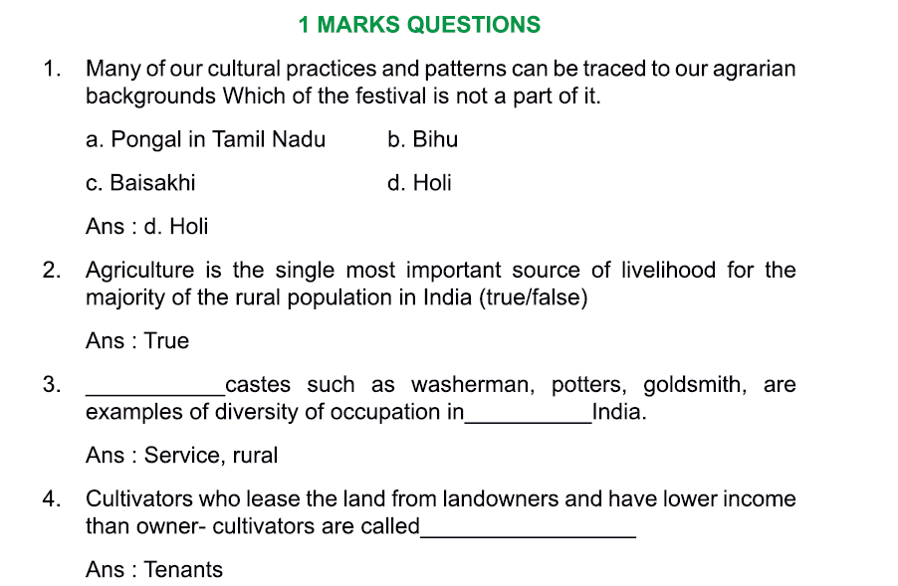
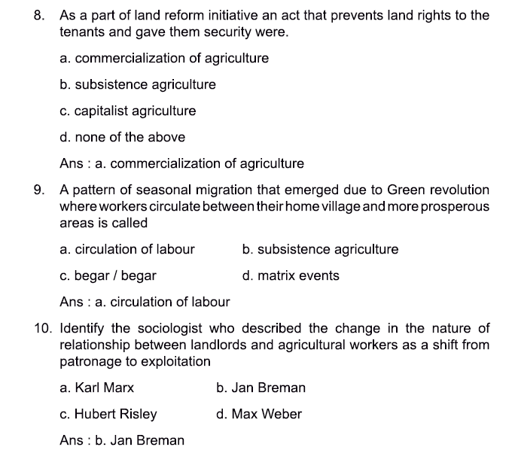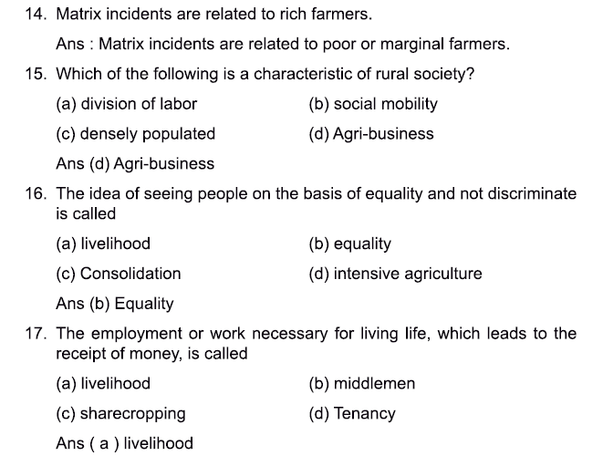

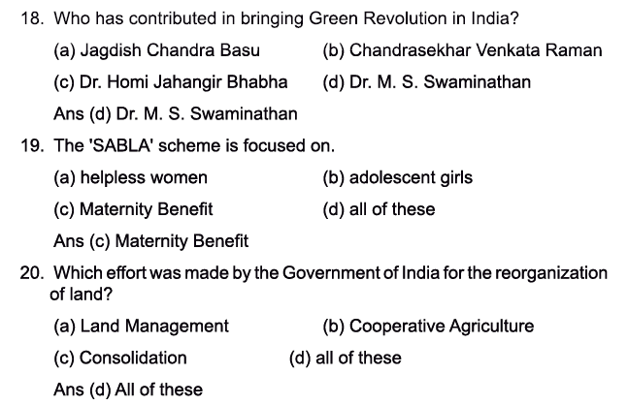
- MARK QUESTION ANSWERS:
- What are the various occupations followed in rural society?
Ans: Although agriculture is the single most important source of livelihood for the majority of rural population, many other activities that support agriculture and rural life are also a source of livelihood for people in rural India. For example, potters, carpenters, weavers, ironsmiths and goldsmiths. Rural life also supported many specialists such as story tellers, astrologers, priests, oil pressers and water-distributors.
- What does ‘agrarian structure’ refer to?
Ans: The term agrarian structure is often used to refer to the structure or distribution of landholding. Because agricultural land is the single most single most productive resource in rural areas, and therefore access to it shapes the rural class structure. There is a complex relationship between caste and class and typically the upper and middle castes also had the best access to land and resources, and hence to power and privilege.
- What does the term ‘begar’ mean?
Ans: ‘Begar’ or free labour was prevalent in many parts of northern India. Members of low ranked case groups had to provide labour for a fixed number of days per year to the village zamindar or landlord. Although such practices have been abolished legally, they continue to exist in many areas.
- What is the ‘Raiyatwari system’? Ans: Areas that were directly under the British rule had the ‘Raiyatwari’ system of land settlement (raiyat means cultivator in Telugu). In this this system, the ‘actual cultivators’ (who were themselves often landlords and not cultivators) rather than the zamindars were responsible for paying the tax. Because the colonial government dealt directly with the farmers or landlords, rather than through overlords, the burden of taxation was less and cultivators had more incentive to invest in agriculture. As a result, these areas became relatively more productive and prosperous.
- What was the condition of Indian agriculture after independence?
Ans: The condition of Indian agriculture was dismal after independence. It was marked by:
- low productivity
- dependence on imported food grains and
- intense poverty of a large section of the rural population.
- What are ‘benami transfers’? Ans: There were many loopholes and other strategies through which most landowners were able to escape from having their surplus land taken over by the state under the Land ceiling Act. While some very large estates were broken-up, in most cases landowners managed to divide the land among relatives and others, including servants, in so-called ‘benami transfers’-which allowed them to keep control over the land (in fact not in name).
- How did the Green Revolution benefit Indian agriculture initially? Ans: The Green Revolution was a government programme of agricultural modernization. Initially it benefitted the Indian agriculture by: increased agricultural productivity due to the new technology and self- sufficiency in food grain production for the first time in decades.
- Why have areas like eastern UP and Telangana witnessed inter-caste violence in recent years? Ans: A negative outcome of the Green Revolution strategy was the worsening of regional inequalities. The areas that underwent this technological transformation became more developed while others stagnated. As a result, we find agriculture in states such as Bihar and eastern UP, and in dry regions such as Telangana to be relatively undeveloped. The sharp caste and class inequalities together with exploitative labour relations, in these regions has given rise to various types of inter-caste violence in recent years.
- What are various factors behind Kerala’s ‘mixed economy’? Ans: Political mobilization, redistributive measures and linkages to an external economy (primarily the Gulf countries) have brought about substantial transformation of the rural countryside. Far from the rural being primarily agrarian, the rural in Kerala is a mixed economy that integrates some agriculture with a wide network of retail sales and services, where a large number of families are dependent on remittances from abroad.
- What do you mean by ‘feminization of agriculture’? Ans: In poor areas where male family members spend much of their time working outside, cultivation has become primarily a female task. Women are also emerging as the main source of agricultural labor leading to the ‘feminization of agricultural labor force’.
- Differentiate between peasants and farmers. Ans: Peasants- are agriculturists who primarily produce for themselves and unable to produce for the market. Farmers are those agriculturists who are able to produce surplus over an above the needs of the family and are linked to the market.
4 marks Question Answers:
- Explain the various factors behind the increasing farmer’s suicide in India
Ans: While farmers in India for centuries have periodically faced distress due to drought, crop failures, or debt, the phenomenon of farmers’ suicides appears to be new. Sociologists have attempted to explain this phenomenon by looking at the structure and social changes that have been occurring in agriculture and agrarian society. Such suicides have become ‘matrix events’ that is, a range of factors coalesce to form an event.
Many farmers who have committed suicides were marginal farmers, who were attempting to increase their productivity primarily by practicing Green Revolution methods. However, undertaking such production meant facing several risks:
- Cost of production has increased tremendously due to decrease in agricultural subsidies
- Markets are not stable
- Many farmers borrow heavily in order to invest in expensive inputs and improve production
- The loss of either the crop (due to spread of disease and pests, excessive rainfall, or drought), and in some cases, lack of an adequate support or market price means that farmers are unable to bear the debt burden or sustain their families.
- Such distress is compounded by the changing culture in rural areas, in which increased incomes are required for marriages, dowries and to sustain new activities and expenses, such as education and medical care.
Add this for 6marks:
The pattern of farmers suicides point to the significant crises that the rural areas are experiencing. Agriculture for many is becoming untenable, and state support for agriculture has declined substantially. In addition, agricultural issues are no longer key public issues, and lack of mobilization means that agriculturists are unable to form powerful pressure groups that can influence policy making in their favour.
Suicides of farmers is basically associated with debt, as well as, natural disasters, resulting in the failure of agricultural produce. Pradhan Mantri Fasal Bima Yojana, Gram Udyog se Bharat Uday Abhiyan and National Rurban Mission are some of the schemes of the government of India which may provide unifies help to farmers all over the country. These schemes are also helpful in providing quality life to rural India.
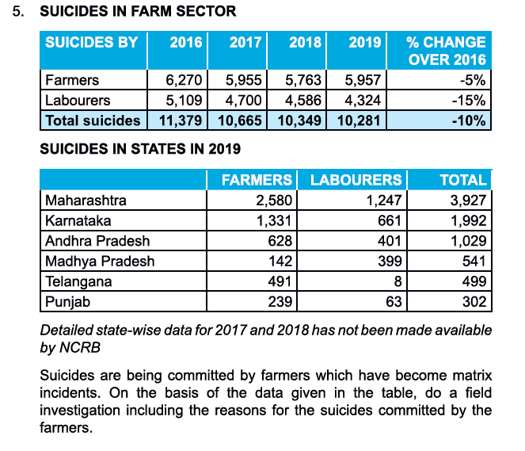

- Explain the agrarian structure of Rural society. (4marks)
Ans: The term agrarian structure is often used to refer to structure or distribution of land holding. Agricultural land is the single most important resource and form of property in rural society. There is no straightforward relationship between caste and class in rural India. In many cases there is a correspondence between caste and class as one moves down the hierarchy. But in some cases, it is not so. For example, Brahmins although being the higher caste are not the major landowners. Examples of the dominant landowning groups are the Jats and Rajputs of UP, the Vokkalingas in Andhra Pradesh and the Ja Sikhs of Punjab. The points below highlight the main components of the agrarian structure in rural society:
Large and medium landowners: Own large amount of land, earlier known as zamindars.
Small and marginal landowners: these are small farmers who have less land. They are only able to produce grains for their family’s consumption. They do not have additional products to sell in the market.
Tenants: These are the cultivators who lease the land from landowners.
Landless agricultural labourers: Have no land of their own, work for others.
Status of women: Law gives equal land rights to women. But the women’s name is only a formality as men have authority over the land.
- Examine the caste and class relationship in rural society (4marks)
Ans: The class structure in agrarian society can be understood through the caste system and there is a complex relationship between the two. However, this relationship is not always straightforward.
We might expect that the higher castes have more land and higher incomes. And that there is a correspondence between caste and class as one moves down the hierarchy. In many areas this is broadly but not exactly true. For instance, in most areas the highest caste, the Brahmins, are not major landowners, and so they fall outside the agrarian structure although they are a part of rural society.
In most regions of India, the major landowning groups belong to the upper castes. In each region, there are usually just one or tow major landowning castes, who are also numerically very important. Such groups are termed by sociologist M/N Srinivas as dominant castes. In each region, the dominant caste is the most powerful group, economically and politically and also dominates the local society. Examples of dominant landowning groups are the Jats and Rajputs of U.P, the Vokkaligas and Lingayats in Karnataka, Kammas and Reddis in Andhra Pradesh, and Jat Sikhs in Punjab.
For 6marks add this: Explain the agrarian structure of rural society and also examine the caste and class relationships that exists.
While dominant landowning groups are usually middle of hight ranked castes, most of the marginal farmers and landless belong to lower caste groups. In official classification they belong to the Scheduled Caste (SC) or Scheduled Tribe (ST) or Other Backward Caste (OBC).
In many regions of India, the former ‘Untouchable’ or dalit castes were not allowed to own land and they provided most of the agricultural labour for the dominant landowning groups. This also created a labour force that allowed the landowners to cultivate the land intensively and get higher returns.
Extra notes (general knowledge):
When the rural Indian society was examined post-independence three main agricultural classes came to be observed along with a fourth class that was composed of people who practised non-agriculture related activities. The three agriculturist classes are the landowners, the tenants, and the labourers. The approximate population shares of each class as given by A. R. Desai are as follows:
- Non-agriculturists are about 20%.
- Landowners are around 22%.
- Tenants are about 27%.
- And the agricultural labourers are approximately 31%

- Mention the loopholes found in the implementation of the land ceiling Act
Ans: While the Land Ceiling Act was implemented to bring about certain reforms after independence, there were certain loopholes mentioned below:
- Most landowners were able to escape from having their surplus land taken over by the state.
- Some very large estates were broken up and in most cases, landowners managed to divide the land among relatives and others, including servants, in so-called ‘benami transfers’ which allowed them to keep control over the land (in fact not in name).
- In some places, some rich farmers actually divorced their wives (but continued to live with them) in order to avoid the provisions of the Land Ceiling Act which allowed a separate share for unmarried women but not for wives.
- What were the major land revenue systems followed by the British in India? Ans: During the colonial period most, rural areas were administered through one of the two systems explained below:
- Zamindari system: In this system the landlord was considered the owner of the land. The farmer did not have direct contact with the government but the land tax was paid to the government through the landlords.
- Raiyatwari system: The word ‘raiyat’ means farmer and in this system the land tax was directly paid to the government by the farmers. In this system the landlords were removed between the government and the farmers.
- Explain the ‘Green Revolution’ program OR Explain the regional inequalities created due to the Green Revolution programme
Ans: The Green Revolution was a government programme implemented in 1960’s and 70’s that aimed at modernization of agriculture in.
-It was largely funded by international agencies that provided high yielding variety (HYV) or hybrid seeds along with pesticides, fertilizers and other inputs to farmers.
-The Green Revolution programme was introduced only in areas that had assured irrigation, because sufficient water was necessary for the new seeds and methods of cultivation.
-It was targeted mainly in the wheat and rice-growing areas. Hence only certain parts of India such as the Punjab, western U.P, coastal Andhra Pradesh and parts of Tamil Nadu received the first wave of the Green Revolution package.
For regional inequalities include this:
Agricultural productivity increased sharply because of the new technology and the green Revolution has been considered a major achievement of the government and of the scientists who contributed to the effort. In most of the green revolution areas, it was primarily the medium and large farmers who were able to benefit from the new technology.
This was because inputs were expensive, and small and marginal farmers could not afford to spend as much as large farmers to purchase these inputs. In addition, it was the farmers who were able to produce a surplus for the market who were able to real the most benefits from the Green Revolution and from the commercialization of agriculture that followed.
Thus in the first phase of the Green Revolution, in the 1960’s and 1970’s, the introduction of new technology seemed to be increasing inequalities in rural society. In addition, the introduction of machinery such as tillers, tractors, threshers and harvesters (in areas such as Punjab and parts of Madhya Pradesh) led to the displacement of the service caste groups who used to carry out these agriculture related activities. This process of displacement also increased the pace of rural- urban migration.
Then ultimate outcome of the Green Revolution was a process of ‘differentiation; in which the rich grew richer and many of the poor stagnated or grew poorer.
The areas that underwent technological transformation became more developed while other areas stagnated. For instance, the Green Revolution was promoted more in the western and southern parts of the country. As a result, we find agriculture in states such as Bihar and in eastern U.P, and in dry regions such as Telangana, to be relatively undeveloped. These are also regions that continue to have an entrenched ‘feudal’ agrarian structure, in which the landed castes and landlords maintain power over the lower castes, landless workers and small cultivators. The sharp caste and class inequalities, together with exploitative labour relations, in these regions has given rise to various kinds of violence (including inter-caste violence) in recent years.
- Mention the various aspects of social transformation in rural society as a result of the Green Revolution Program
Ans: Due to the Green Revolution agricultural productivity increased sharply because of the new technology and for the first time in decades India became self- sufficient in food grain production.
However, there were some negative social and economic effects of the green revolution in both the first and second phases.
1st phase:
-Only medium and large farmers benefitted
- displacement of tenancy cultivators
- displacement of service caste groups
- worsening of economic condition for agricultural workers due to rising prices and shift in the mode of payment
2nd phase:
-Commercialization and market -oriented cultivation leading to livelihood insecurities
-Worsening of regional inequalities giving rise to inter-caste violence
-traditional system of cultivation practices and indigenous seeds being lost
-Environmental hazards
- The medium and large farmers benefitted from the new technology. This was because inputs were expensive, and small and marginal farmers could not afford to spend as much as large farmers, to purchase these inputs.
- It was only the farmers who were able to produce a surplus for the market who were able to reap the most benefits from the Green Revolution and from the commercialization of agriculture that followed.
- ‘Commercialization of Agriculture is indicative of Capitalists Agriculture according to some scholars. Explain
Ans: The advent of commercialization of agriculture in the years after the Green Revolution also resulted into a loosening of traditional bonds or hereditary relationships between farmers or landowners and agricultural workers (known as bonded labour). This change in the nature of relationship between landlords (who usually belonged to the dominant castes) and agricultural workers (usually low caste), was a shift from ‘patronage to exploitation’. Such changes took place in many areas where agriculture was becoming more commercialized, i.e. where crops were being grown primarily for sale in the market.
The transformation in labour relations is indicative of a transition to capitalist agriculture. Because the capitalist mode of production is based on the separation of the workers from the means of production (in this case land), and the use of ‘free’ wage labour.
In general, it is true that farmers in the more developed regions were becoming more oriented to the market. As cultivation became more commercialized these rural areas were also becoming integrated into the wider economy. This process increased the flow of money into villages and expanded opportunities for business and employment.
In this way we see how commercialization of agriculture is indicative of capitalists agriculture.

- Discuss the emergence of new regional elites in rural society.
Ans: In 1960’s and 1970’s India witnessed the enrichment of medium and large farmers who adopted new technologies and benefitted from the Green Revolution.
- In agriculturally rich regions, farmers belonging to dominant caste began to invest their profits in other ventures.
- There was a surge of new entrepreneurial groups and regional elites who became economically as well as politically dominant
- Spread of higher education and an increase in private and professional colleges in rural areas allowed them to educate their children
- Most of the children of farmers who had access to this education joined professional white-collar occupations and started business. This led to the expansion of urban middle class.
- Explain Jan Breman’s concept of ‘Foot loose labour’.
Ans: A significant change in rural society that is linked to the commercialization of agriculture has been the growth of migrant agricultural labour.
As a livelihood strategy, men migrate out periodically in search of work and better wages, while women and children are often left behind in their village with elderly grandparents. Migrant workers come mainly from drought-prone and less productive regions, and they go to work for part of the year on farms in Punjab and Haryana, or on brick kilns in U.P or construction sites such as New Delhi or Bangalore. These migrant workers have been termed as ‘footloose labour’ by Jan Breman, but this does not imply freedom.
- Describe contract farming (2marks)
Ans: Contract farming involves agricultural production being carried out on the basis of an agreement between the buyer and the farm producers. Sometimes it involved the buyer specifying the quantity required and the price, with the farmer agreeing to deliver the produce at a future date.
For 4 marks add this: In such ‘contract farming’ systems, the company identifies the crop to be grown, provides seeds and other inputs, as well as the know-how and also the working capital. In return, the farmer is assured of a market because the company guarantees that it will purchase the produce at a predetermined fixed price.
Contract farming is very common now in the production of specialized items such as cut flowers, fruits such as grapes, figs and pomegranates, cotton and oilseeds. While contract forming appears to provide financial security to farmers, it can also lead to greater insecurity as farmers become dependent on these companies for their livelihoods.
Contract farming of export-oriented products such as flowers or gherkins also means that agricultural land is diverted away from food grain production.

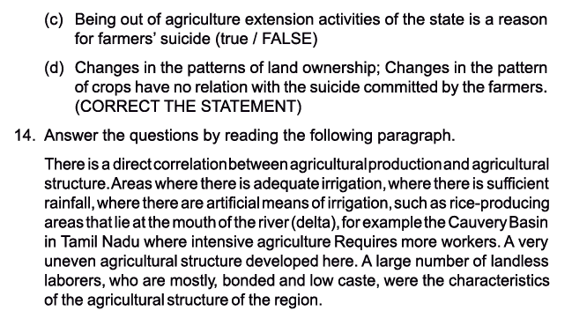
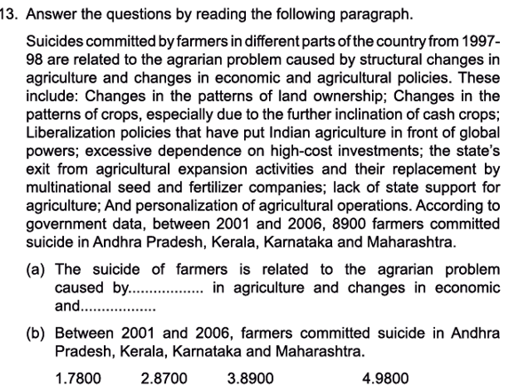

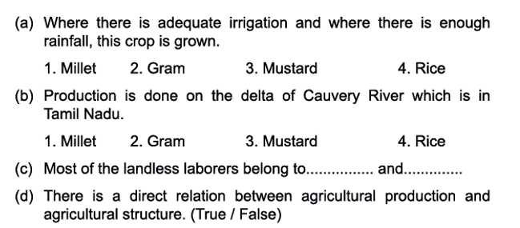
Answers:
6-mark Question Answers:
- Enumerate the social consequences of Green Revolution

Social Consequences of Green Revolution
The green revolution has been basically a contribution of the middle-class peasantry who have had traditionally a strong attachment to land and agriculture as a mode of life and livelihood. Green revolution made a departure from the traditional pattern. The family mode of production continued but authority passed from the older to the younger generation. The new agriculture required the skill in the peasant to negotiate with banks, revenue authorities, marketing bodies and block administration.
The new peasant was also required to consult the experts and technicians for irrigation, soil testing, the use of fertilizers and seeds. This role was performed by the younger generation which was educated comparatively more than the older generation. The Green revolution had led to the consolidation of the status of the middle peasantry as a dominant class. The upper caste class groups which traditionally dominated was replaced by the middle peasantry or had to compete with them to maintain their traditional status and power.
They employed a variety of strategies of cooperation, compromises and confrontation. These set of social forces in rural society led increasingly to social polarization, large scale migration to cities, social tensions. The relationship between the middle-class peasantry and the lower castes declined and led to exploitation and violence.

- Explain the various land reforms introduced in India after Independence.

Agrarian Changes After Independence in Rural Society
In many ways independence from colonial rule in 1947 marked the beginning of a new phase in the history of Indian agriculture. Having evolved out of a long struggle against colonial rule with the participation of the people from various social categories, the Indian state also took over the task of supervising the transformation of its stagnant and backward economy to make sure that the benefits of economic growth were not monopolized entirely by a particular section of society.
It is with this background that development and reforms in rural society emerged as a strategy of economic change and an ideology of the new regime.
However, at the micro-level the structures that evolved during colonial rule still continued to exist. The local interests that had emerged over a long period of time continued to be powerful in the Indian countryside even after the political climate had changed. According to Daniel Thorner the earlier structure of land relations and debt dependencies where a small section consisting of few landlords and money lenders were dominant continued to prevail in the Indian countryside. The nature of property relations, the local values that related social prestige negatively to physical labour and the absence of any surplus with the actual cultivator for investment on land ultimately perpetuated stagnation. This complex of legal, economic and social relations typical of Indian countryside served to produce an effect that Thorner described as a built -in depressor.

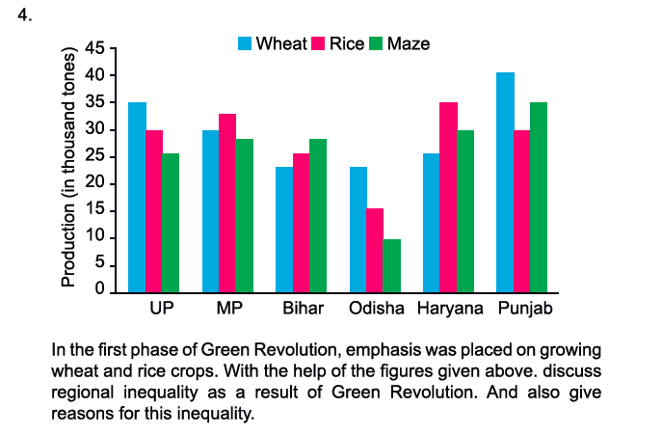
Textbook Questions Solved:
